SNOWFLAKE PERFORMANCE MANAGEMENT
CLUSTERING
What is a cluster key?
- Snowflake creates cluster keys on certain columns to create Subset of rows to locate the data in micro-partitions and this helps us to avoid full table scans & improves the efficiency of table scans especially dealing with large tables
- Snowflake automatically maintains these cluster keys and produces well clustered tables
- Cluster keys are not always ideal and can change over time
- We can Manually customize these cluster keys also

Let’s understand practically
Create a table ‘t0’
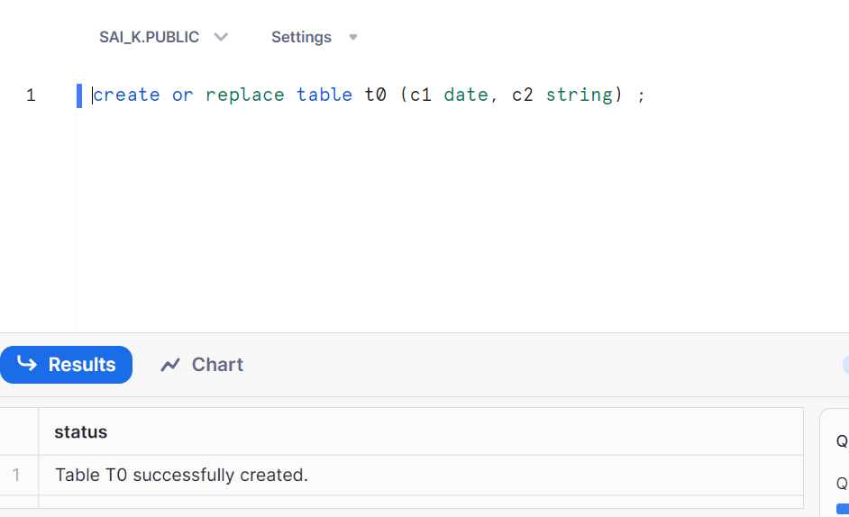
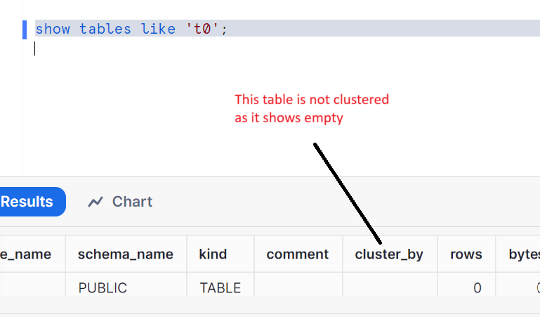
Clustering by columns
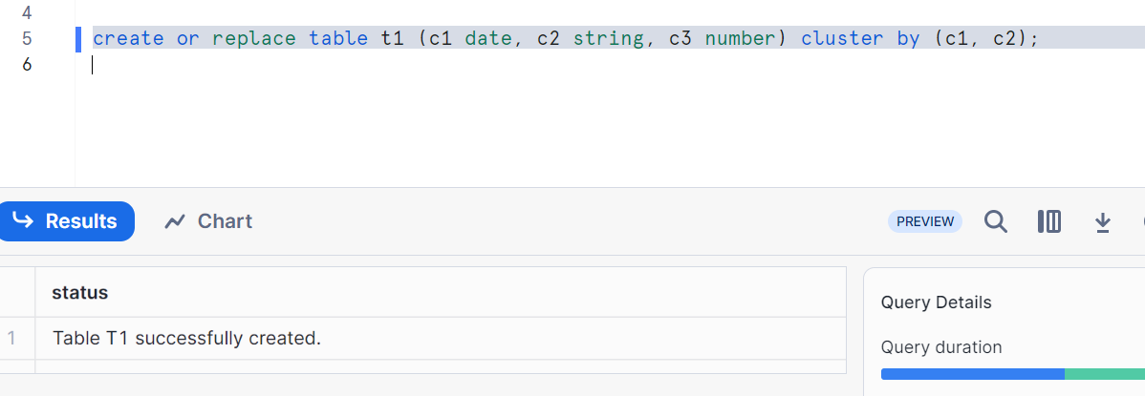
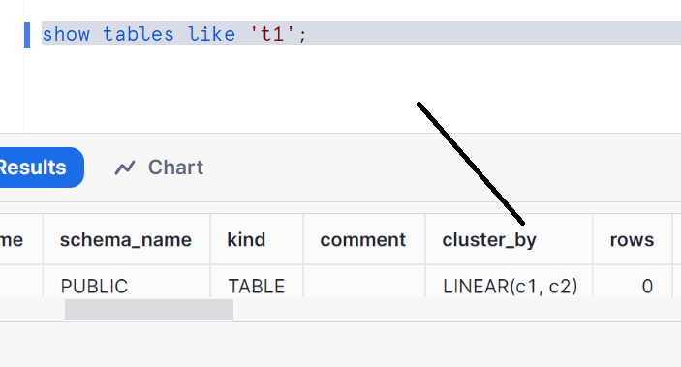
Clustering by expressions
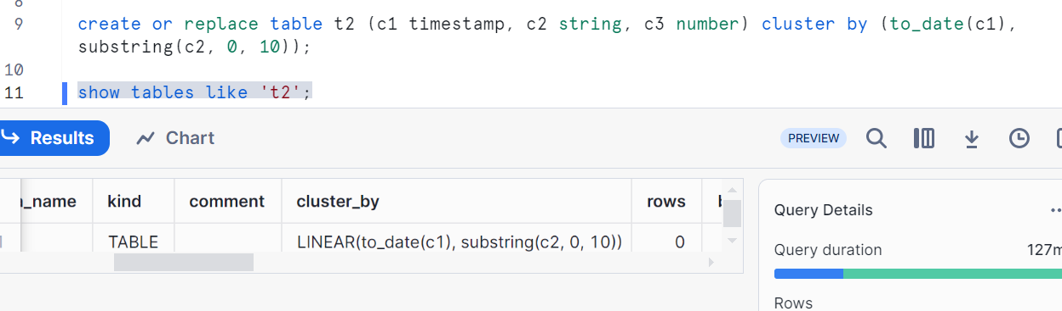

Cluster by paths in variant columns (we can see later in detail)
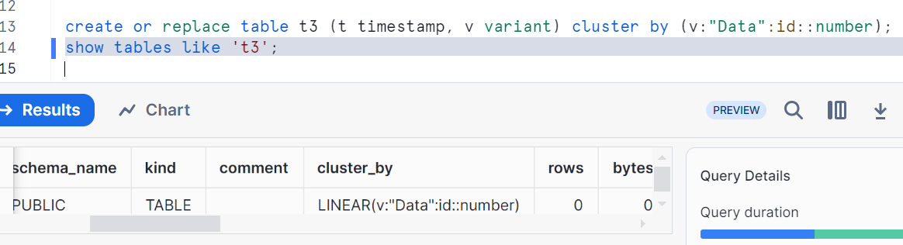
When you try to get the clustering info on non-clustered table. It gives error and syntax would be system$clustering_information
We had not given any clustering key for ‘t0’ table, hence error
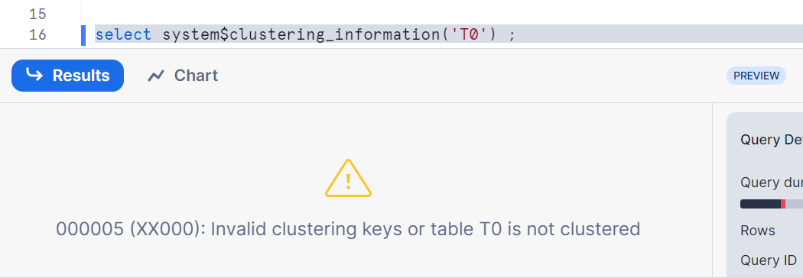
Clustering information based on column
